**Driving Retail Innovation with Machine Learning: Addressing Key Challenges and Strategies**

**Introduction**

Machine learning (ML) is reshaping the retail industry by enhancing customer experiences, optimising inventory, and driving sales. However, challenges like data quality, integration, and "black box" model interpretability persist. This report addresses these challenges and explores opportunities, providing real-world examples and strategies.

**1. Quality vs. Quantity of Data in Machine Learning**

Machine learning models thrive on large datasets, but the success of these models hinges on the balance between quality and quantity of data. In retail, businesses collect massive amounts of data from online interactions, in-store sales, and loyalty programs. However, not all data is of equal value, and focusing solely on quantity can lead to inaccurate predictions or flawed insights (Provost & Fawcett, 2023).

**1.1 Challenge: Data Quality in Retail**

In retail, poor-quality data, such as inconsistent customer information or incorrect sales records, introduces errors into machine learning models. These inaccuracies reduce model performance, which can lead to poor product recommendations or faulty inventory decisions, resulting in revenue loss or dissatisfied customers.

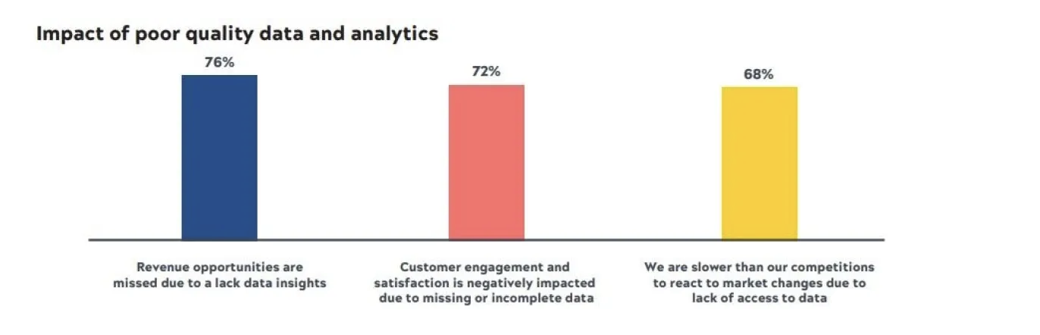

*Figure 1: Impact of poor quality data and analytics (Source: SnapLogic)*

**1.2 Opportunity: Leveraging High-Quality Data**

Retailers should prioritise the collection of accurate customer data to enhance machine learning models. Precise, well-maintained data leads to better segmentation, improved recommendation systems, and operational efficiency, ultimately boosting customer satisfaction and business performance.

**1.3 Real-World Example**

Amazon excels in using customer data for personalised recommendations. By ensuring the quality of customer interaction data (e.g., browsing history, purchase history), Amazon’s recommendation engines are highly accurate. They focus on precise data points rather than overwhelming the system with low-quality inputs, resulting in more relevant suggestions for customers and higher conversion rates (Agrawal et al., 2018).

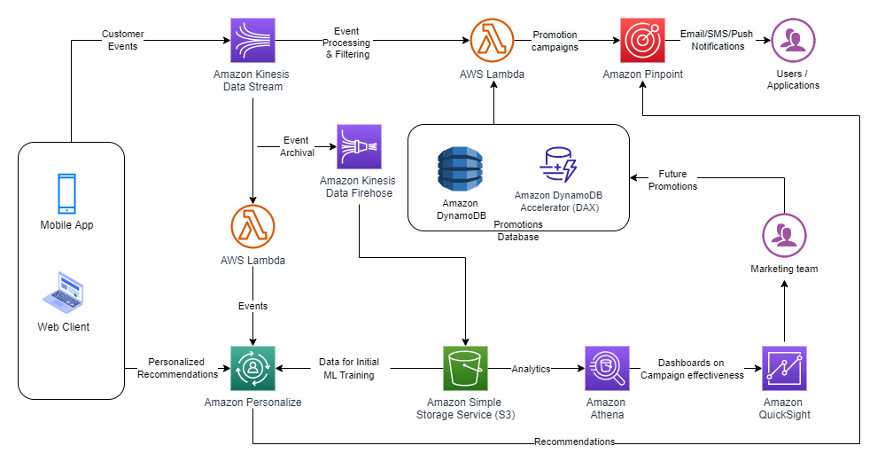

*Figure 2: Digital shopping experience architecture (Source:* [*Amazon AWS*](https://aws.amazon.com/blogs/architecture/amazon-personalize-customer-outreach-on-your-ecommerce-platform/)*)*

**2. Data Integration from Various Sources**

Data integration is crucial for machine learning success in retail, as retailers gather information from multiple touchpoints like online purchases, social media, and in-store transactions. However, combining this data into a usable format presents challenges.

**2.1 Challenge: Complexity of Data Integration**

Retailers often face difficulties in integrating data from various platforms. Each platform may use different formats, structures, and standards, leading to incompatibility issues. For instance, data from in-store transactions may be structured differently from website interactions or social media data, complicating the integration process.

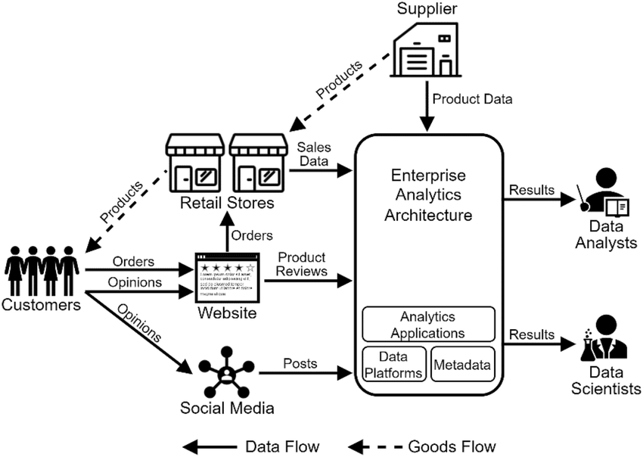

*Figure 3: High-level overview of the retail scenario (Source:* [*ResearchGate*](https://www.researchgate.net/figure/High-level-overview-of-the-retail-scenario_fig1_379924572)*)*

**2.2 Opportunity: Unified Data Platforms**

Unified data platforms, like data lakes or CDPs, can address integration challenges by merging structured and unstructured data into a single system. This allows retailers to gain a more comprehensive view of their customers and improve decision-making with machine learning models. Investing in real-time data integration tools will further enhance retailers' ability to adapt to customer behaviours swiftly.

**2.3 Real-World Example**

Zara integrates data from online purchases, in-store behaviour, and social media to predict fashion trends and manage inventory. By using machine learning models trained on this integrated data, Zara optimises inventory restocking and reduces waste, ensuring they stay ahead of fashion trends and customer preferences. Their ability to seamlessly integrate and analyse data from multiple sources gives them a competitive edge in fast fashion (McKinsey & Company, 2020).

**3. Interpretability in "Black Box" Models**

Machine learning models in retail, especially those based on deep learning, are often labelled as "black boxes" due to their complexity. These models may produce highly accurate predictions, but understanding how the model arrived at its conclusions is challenging, which can be problematic in critical retail decisions such as pricing, product recommendations, or inventory management.

**3.1 Challenge: Black Box Complexity**

The complexity of deep learning models makes it difficult for retail managers to interpret the reasoning behind certain predictions, such as a sudden price change or inventory recommendation. This lack of understanding can lead to hesitation in relying on model outputs, especially in critical decision-making processes.

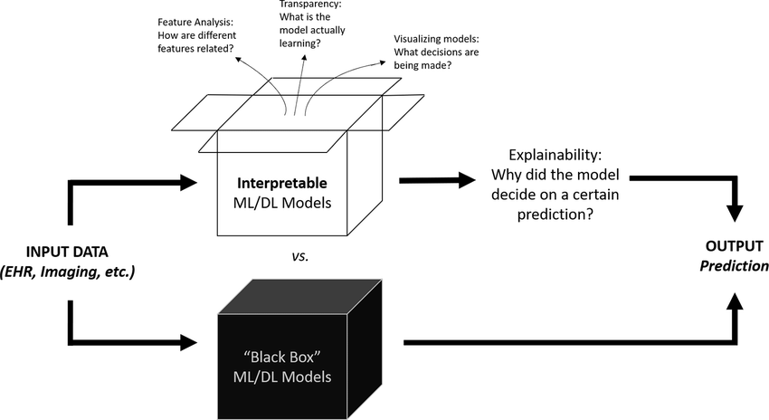

*Figure 4: Black box AI models versus interpretable and explainable AI models (Source:* [*ResearchGate*](https://www.researchgate.net/figure/Black-box-AI-models-versus-interpretable-and-explainable-AI-models-DL-deep-learning_fig2_357757904)*)*

**3.2 Opportunity: Enhancing Interpretability**

Tools like LIME (Local Interpretable Model-agnostic Explanations) and SHAP (Shapley Additive Explanations) enhance model transparency by breaking down predictions into understandable components. These tools allow retailers to identify which factors contribute most to a decision, making complex machine learning models more interpretable and actionable. With LIME and SHAP, retail managers can gain insights into model predictions and make informed decisions with greater confidence.

**3.3 Real-World Example**

Retailers using dynamic pricing models often face the challenge of justifying price fluctuations to customers and stakeholders. Walmart, for example, employs machine learning to optimise pricing strategies and can use tools like SHAP to understand why prices differ across products. Factors such as demand, competitor pricing, and seasonal trends influence pricing, and SHAP helps explain how each factor contributes to the final price. This transparency enables Walmart to justify its pricing strategies, building trust with customers and stakeholders.

**4. Real-World Applications of Machine Learning in Retail**

Machine learning is transforming retail in several ways. Here are some notable applications:

**Customer Segmentation**: Machine learning allows retailers to classify customers based on their purchasing behaviour, preferences, and interactions. By analysing these patterns, retailers can create targeted marketing strategies that resonate with specific customer segments, ultimately enhancing customer engagement and loyalty.

**Recommendation Engines**: Retailers such as Netflix and Amazon use machine learning to analyse browsing and purchasing histories, enabling them to recommend products that are most likely to interest each individual user. This personalised approach helps boost sales and improve the overall customer experience.

**Demand Forecasting**: Machine learning models analyse historical sales data, seasonal trends, and other external factors to predict product demand. By accurately forecasting demand, retailers can optimise their inventory levels, avoid overstocking, and minimise stockouts, leading to better inventory management.

**Fraud Detection**: Machine learning algorithms are effective in identifying anomalies in transaction data, enabling real-time detection of potential fraudulent activity. This capability is especially important in e-commerce, where detecting and preventing fraud can help prevent substantial revenue losses.

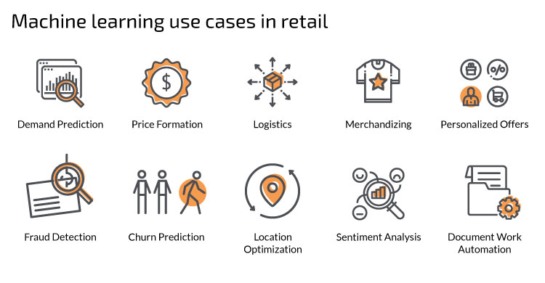

*Figure 5: Machine learning use cases in retail (Source:* [*Experfy*](https://resources.experfy.com/ai-ml/a-fresh-look-machine-learning-retail-ten-top-applications/)*)*

**5. Recommendations and Strategies**

To effectively implement machine learning in retail, organisations should focus on the following strategies that balance technological advancements with practical, actionable steps:

* **Prioritise Data Quality**: Ensuring high-quality data is essential for building reliable machine learning models. Retailers must establish robust data cleaning, filtering, and validation processes to eliminate errors and inconsistencies from their datasets. Leveraging techniques like active learning can further improve data labelling by selecting the most valuable data points for training, ultimately boosting model accuracy and performance. By focusing on quality rather than just quantity, retailers can avoid common pitfalls related to poor data and maximise the effectiveness of their machine learning initiatives.
* **Invest in Data Integration Solutions**: Retailers gather data from various sources, and unifying these data streams is critical to creating a comprehensive view of customers and operations. Investing in unified data platforms such as data lakes or customer data platforms (CDPs) can help businesses integrate structured and unstructured data seamlessly. These platforms allow retailers to merge data from online, offline, and third-party sources into a cohesive model, enabling machine learning applications to function more effectively. This approach also improves the speed and scalability of analytics, making it easier for organisations to respond to real-time trends.
* **Focus on Model Interpretability**: As machine learning models grow more complex, their decisions can become harder to explain. In retail, where pricing, recommendations, and demand forecasting directly affect customer trust and business outcomes, it is essential to ensure that models are transparent. Tools like LIME (Local Interpretable Model-agnostic Explanations) and SHAP (Shapley Additive Explanations) can enhance model interpretability, allowing retail managers to understand how decisions are made and ensure they are fair and aligned with business goals. This not only fosters better decision-making but also ensures compliance with data privacy regulations and improves customer trust in automated systems.

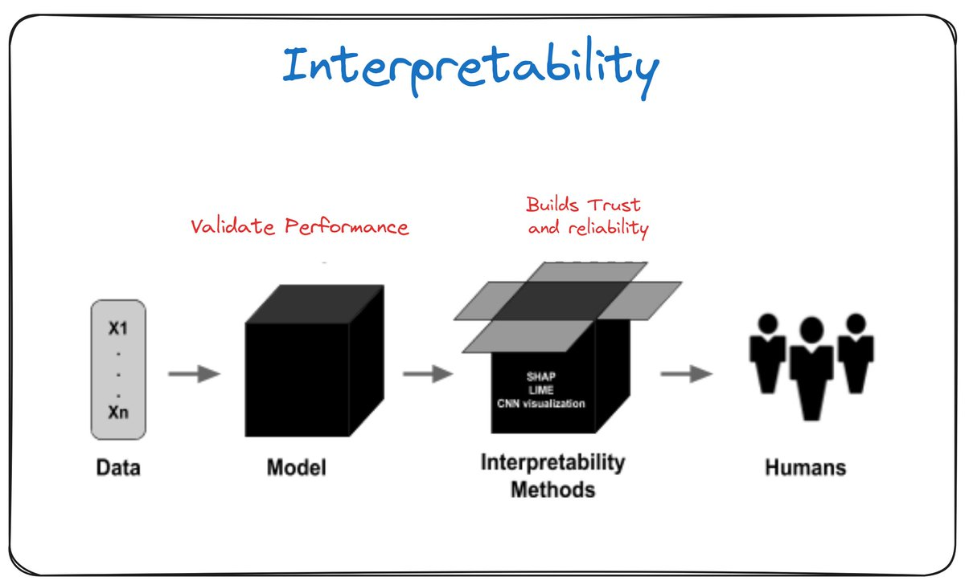

Figure 6: Model interpretability (Source: [Twitter](https://x.com/freest_man/status/1743261628576174410))

**Conclusion**

Machine learning offers significant opportunities for the retail industry, including better customer segmentation, improved demand forecasting, and more efficient inventory management. However, challenges related to data quality, integration, and model interpretability must be addressed for retailers to fully harness the power of ML. By focusing on high-quality data, adopting modern integration platforms, and using interpretability tools, retailers can optimise their operations and provide a more personalised customer experience.

**References**

Agrawal, A., Gans, J., & Goldfarb, A. (2018). *Prediction Machines: The Simple Economics of Artificial Intelligence*. Harvard Business Review Press.

He, X., Zhang, H., & Ren, Z. (2017). Deep Learning for Recommender Systems: A Netflix Case Study. *Proceedings of the 40th International ACM SIGIR Conference*.

Lundberg, S. M., & Lee, S.-I. (2020). A Unified Approach to Interpreting Model Predictions. *Proceedings of the 31st International Conference on Neural Information Processing Systems*.

McKinsey & Company. (2020). How Retailers Can Drive Profitable Growth with Data-Driven Personalization.

Provost, F., & Fawcett, T. (2023). *Data Science for Business: What You Need to Know about Data Mining and Data-Analytic Thinking*. O'Reilly Media.

Ribeiro, M. T., Singh, S., & Guestrin, C. (2016). "Why Should I Trust You?" Explaining the Predictions of Any Classifier. *Proceedings of the 22nd ACM SIGKDD International Conference on Knowledge Discovery and Data Mining*.

Snaplogic. (2020). *The State of Data Management – The Impact of Data Distrust*.